Dear friends,

we would like to invite you to take part in the international ballet school exhibition of non-professional classical ballet. The best dancers can show their skills with no stress as well as represent their school in a wonderful historical building.

This event gives them the chance to compare their effort with the others in a non-competitive way and motivate them to practise and study harder by allowing them to perform in a professional theatre.

The event is organized by Balet, z. s. It is an organization associating former members of the J. K. Tyl Theatre ballet group and former students of the J. K. Tyl Theatre ballet school.

The 10th International BALET GALA Pilsen will be held on 5 November 2017
at 6 pm in the J. K. Tyl Theatre (the Grand Theatre venue) in Pilsen.

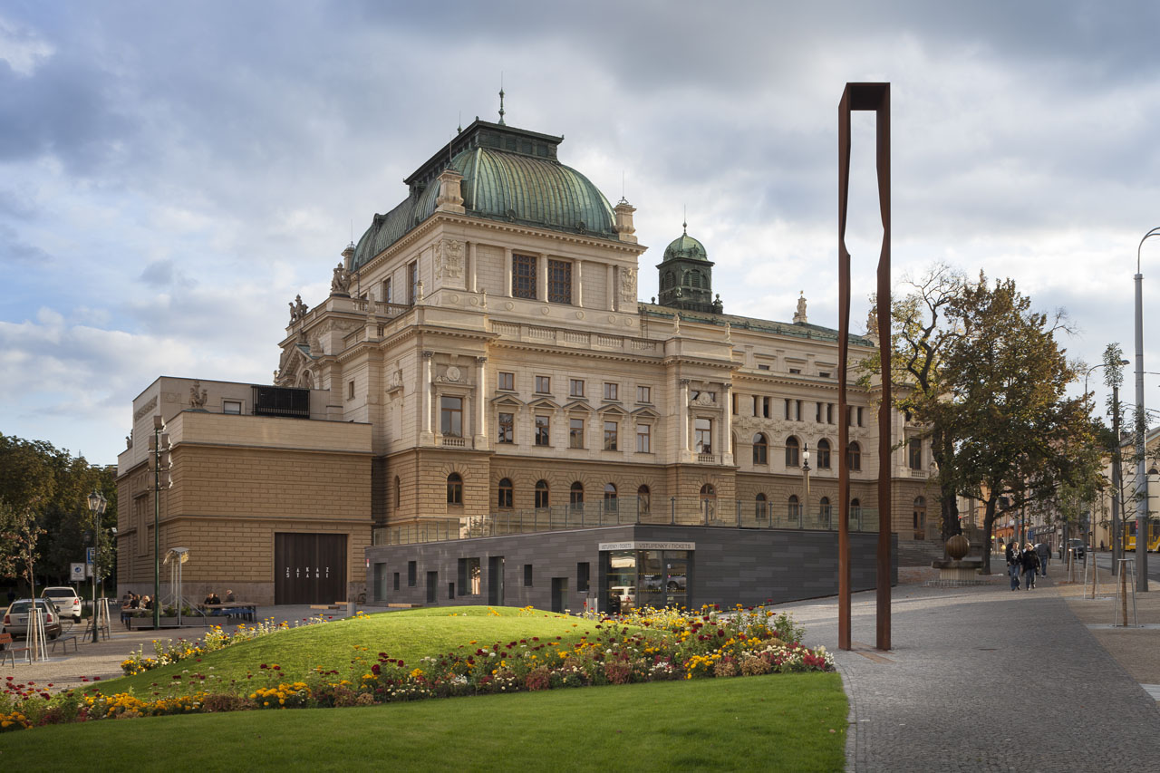

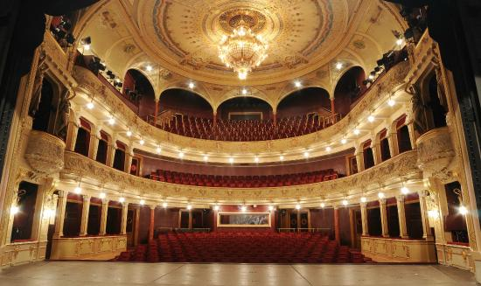

Conditions of participation in BALET GALA 2017, the international ballet school exhibition
1 - Max. 2 ballet performances per school. A single application form is required for each performance.
2 - Choreography based on the classical ballet technique.
3 - A single performance should not be longer then 3 mins.
4 - Solo and group performances allowed (up to 8 dancers).
5 - The youngest dancers need to be 6 years old.
6 - The programme will be scheduled by organisers of BALET GALA 2016. The organisers reserve the right to make an exception in conditions of participation and the programme.
7 - There is no option to ask for special light effects, etc.
8 - The stage rehearsal is with the music.
9 - The music in MP3 audio format only.
10 - The participation fee is € 8 (200 CZK) per dancer. It will be paid during the stage rehearsals.

The stage in J. K. Tyl Theatre:
- size: 10 m in width, 11 m in depth
- floor: roll-out ballet floor
- no special lights or other effects available

Organizers don’t pay the travel costs and accommodation. We can book the accommodation. In some case we can make an exception and partly pay some accommodation costs.
The stage rehearsals timetable will be available at the end of October.

Timetable:
13:30 – entering the theatre, dressing rooms available
14:00 – stage rehearsals
17:00 – the end of stage rehearsals
18:00 – the beginning of the show (one break)
20:30 – the end
Till 21:00 – leaving the theatre

Please, send the application forms till 22 October 2017 to balet.os@email.cz
Send the music in MP3 audio format till 22 October 2017 to SolcPetr@seznam.cz

This year's dance workshops will take place on November 4th. More in a separate invitation.

We look forward to meeting you!
Sarka Zeniskova, Balet, z. s.
www.baletgala.eu
balet.os@email.cz
phone: Sarka +420 723 867 504, Zuzana +420 607 212 564
Join us on Facebook https://www.facebook.com/Spolek-Balet-zs-1689439304608583/

